Bouncig button
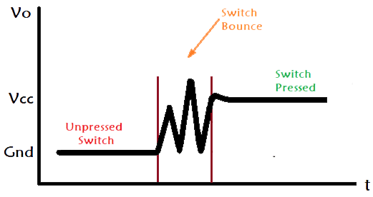
when a mechanical push button is pressed , the contact doesn’t touch and rest but keep oscillating at first then oscillation reduces till they keep a constant contact , the oscillation tricks a reading device such as arduino to think the button was pressed and released multiple times while in fact it was only one press

over comig the problem

